SRS DOCUMENT

Table of Contents

Table of Contents......................................................................................................... ii

Revision History........................................................................................................... ii

1. Introduction............................................................................................................ 1

1.1 Purpose................................................................................................................ 1

1.2 Document Conventions......................................................................................... 1

1.3 Intended Audience and Reading Suggestions.......................................................... 1

1.4 Product Scope....................................................................................................... 1

1.5 References........................................................................................................... 1

2. Overall Description................................................................................................ 2

2.1 Product Perspective............................................................................................... 2

2.2 Product Functions................................................................................................. 2

2.3 User Classes and Characteristics............................................................................ 2

2.4 Operating Environment......................................................................................... 2

2.5 Design and Implementation Constraints................................................................. 2

2.6 User Documentation............................................................................................. 2

2.7 Assumptions and Dependencies............................................................................. 3

3. External Interface Requirements......................................................................... 3

3.1 User Interfaces..................................................................................................... 3

3.2 Hardware Interfaces.............................................................................................. 3

3.3 Software Interfaces............................................................................................... 3

3.4 Communications Interfaces................................................................................... 3

4. System Features..................................................................................................... 4

4.1 System Feature 1.................................................................................................. 4

4.2 System Feature 2 (and so on)................................................................................. 4

5. Other Nonfunctional Requirements..................................................................... 4

5.1 Performance Requirements.................................................................................... 4

5.2 Safety Requirements............................................................................................. 5

5.3 Security Requirements.......................................................................................... 5

5.4 Software Quality Attributes................................................................................... 5

5.5 Business Rules..................................................................................................... 5

6. Other Requirements.............................................................................................. 5

Appendix A: Glossary.................................................................................................. 5

Appendix B: Analysis Models..................................................................................... 5

Appendix C: To Be Determined List.......................................................................... 6

Revision History

| Name | Date | Reason For Changes | Version |
| --- | --- | --- | --- |
|  |  |  |  |
|  |  |  |  |

# 

# 1. Introduction

## 1.1 Purpose

This product is made available to ease the complaint process or issues raised by the general public to the municipal corporation and help optimize the work of municipal corporations to work with ground level workers, speed up the process and save time.

## 1.2 Document Conventions

—---------------------------------------------------------------------------------------

## 1.3 Intended Audience and Reading Suggestions

This project is intended to be used by officials of municipal corporations,workers working for the corporation and by the general public of the area. This website will help to solve issues of the public by minimizing physical contact for medium to small issues, and assign workers their jobs at time of emergency.

## 1.4 Product Scope

The purpose of this web application is to ease the public's complaint process related to general issues for which the corporation is responsible. This helps ground level workers have good interaction with the appropriate authority according to the condition. This web application helps manage the issue of public, assign jobs to ground worker and helps manage revenue for the corporation.

## 1.5 References

<https://www.studocu.com/in/document/st-josephs-college-autonomous/bachelors-of-commerce/student-management-system-srs/17638223>

<https://1000projects.org/software-requirements-specification-student-management-system.html>

# 2. Overall Description

## 2.1 Product Perspective

The perspective of this product is to create a platform where the public can easily raise general issues and municipal corporations can easily manage their budgets and assign jobs to the worker and show real time status to the person who raised the issue.

## 2.2 Product Functions

Functional Requirements

1. The system will have four kinds of users.
   * Administration
   * General public
   * workers
   * Event organizer
2. The clubs can open an event in this system and manage the event through this system properly by following this way
   * They can create an event on this platform.
   * They can take register students who are interested to participate this event
   * They can send SMS or mail to the students by using this system.
   * They can manage all of the student’s information by this system and they can download student information from this system.
   * They can make certificates for the students through this system. For this we give some template of certificates. They need to use one of them to make a certificate.
3. Students can see all the events and can also see the details of this event and they can register them for participating in a particular event. They can also buy passes for an event.
4. The main admin is university authority. They can create a club, add an executive member of a club, remove an executive from a club and update news and notices and academic calendar of the university.

Non-Functional Requirements:

1. The system has strong security.
2. The system manages all the student information sequerly and must verify the students who come from a university who are from a particular university.
3. The system manages the payment issues perfectly.
4. The system is user friendly.

## 2.3 User Classes and Characteristics

There are three Character of use:

1. University Students (they are the user as well as the club members if any)
2. University Club (they host event for college and recruit members for a particular event )
3. University Authority (Any technical issues are solved by this person so he is the most important person.)
4. Non-University Event Manager (any Event done in college by an external entity are part of this group)

## 2.4 Operating Environment

For accessing this system a database will be required which will be made in MySQL. Users will require a tab or mobile phone with a minimum 28 API Level of Android.

## 2.5 Design and Implementation Constraints

<Describe any items or issues that will limit the options available to the developers. These might include: corporate or regulatory policies; hardware limitations (timing requirements, memory requirements); interfaces to other applications; specific technologies, tools, and databases to be used; parallel operations; language requirements; communications protocols; security considerations; design conventions or programming standards (for example, if the customer’s organization will be responsible for maintaining the delivered software).>

## 2.6 User Documentation

<List the user documentation components (such as user manuals, on-line help, and tutorials) that will be delivered along with the software. Identify any known user documentation delivery formats or standards.>

## 2.7 Assumptions and Dependencies

<List any assumed factors (as opposed to known facts) that could affect the requirements stated in the SRS. These could include third-party or commercial components that you plan to use, issues around the development or operating environment, or constraints. The project could be affected if these assumptions are incorrect, are not shared, or change. Also identify any dependencies the project has on external factors, such as software components that you intend to reuse from another project, unless they are already documented elsewhere (for example, in the vision and scope document or the project plan).>

# 

# 

# 

# 

# 

# 

# 3. External Interface Requirements

## 3.1 User Interfaces

0) Students can register on this platform by giving the following information. This is required for those students who are willing to be an executive member of any club. It is not necessary for the general user.

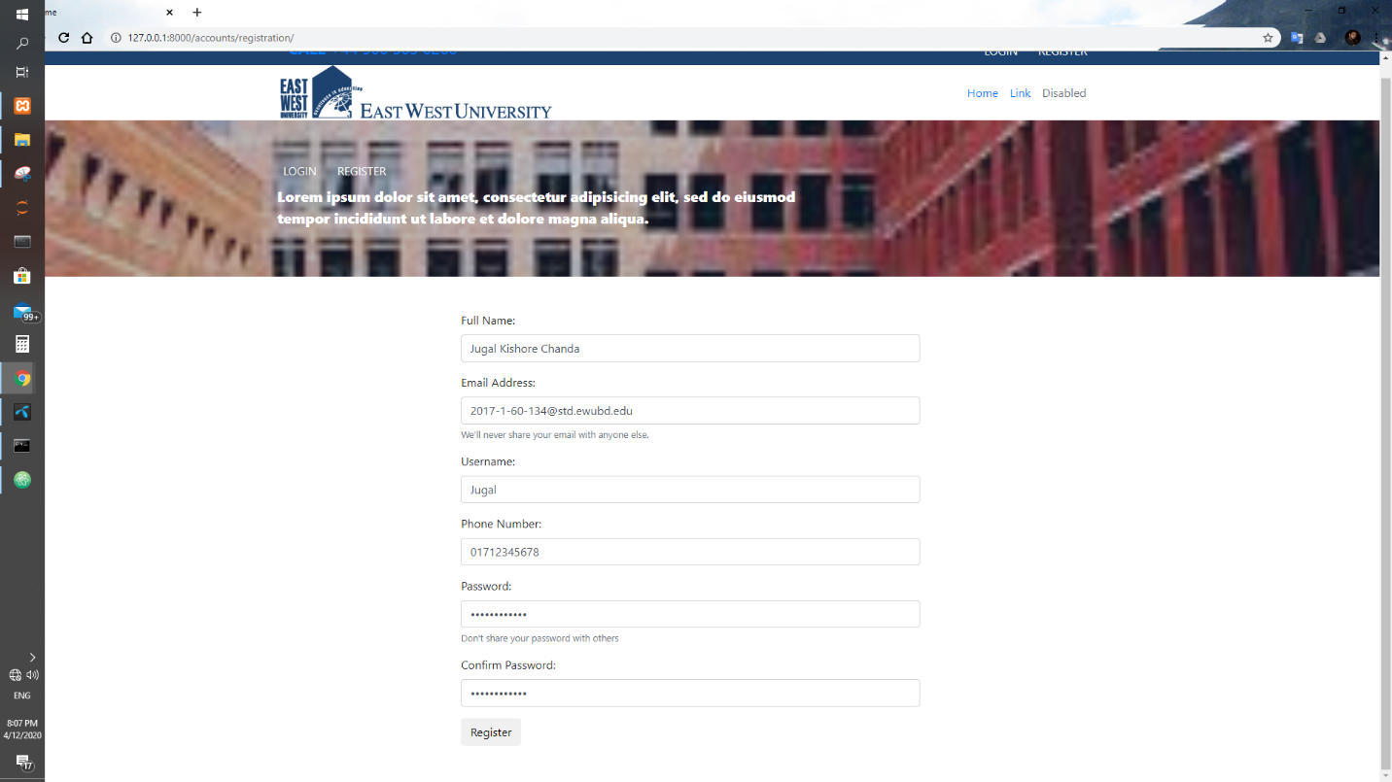

1) Login Admin Panel:

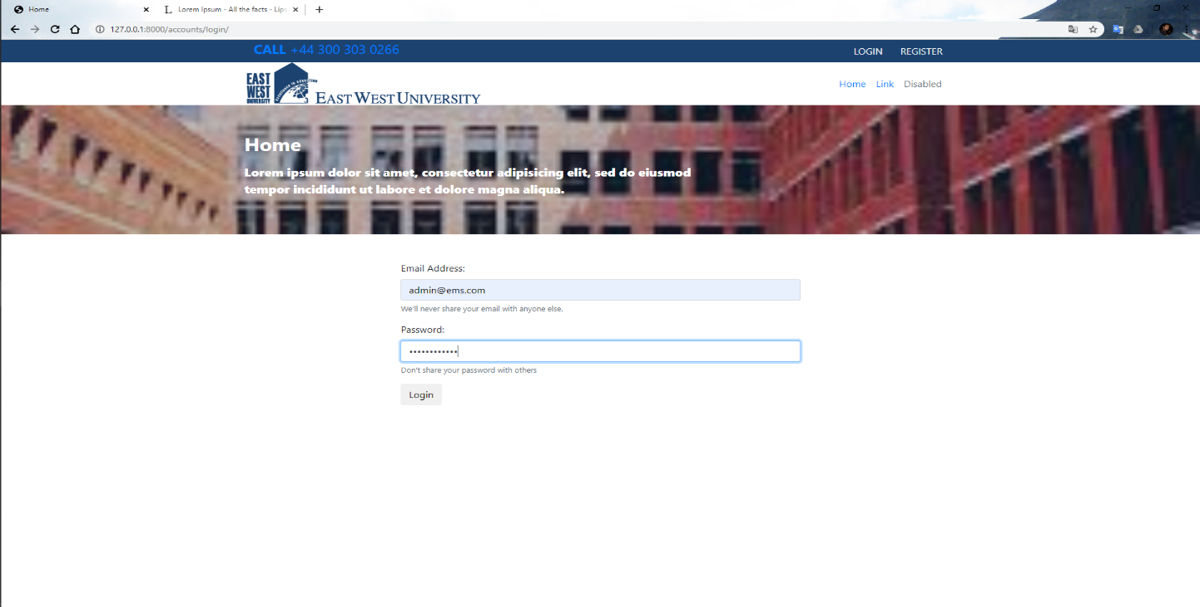

2) Admin Dashboard

This dashboard is accessed by university authorities.

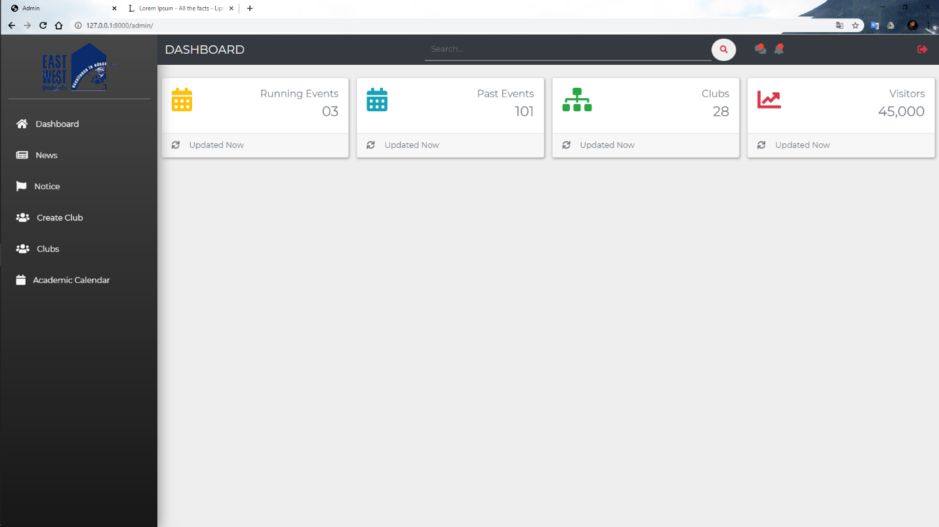

3) University authorities can add recent news.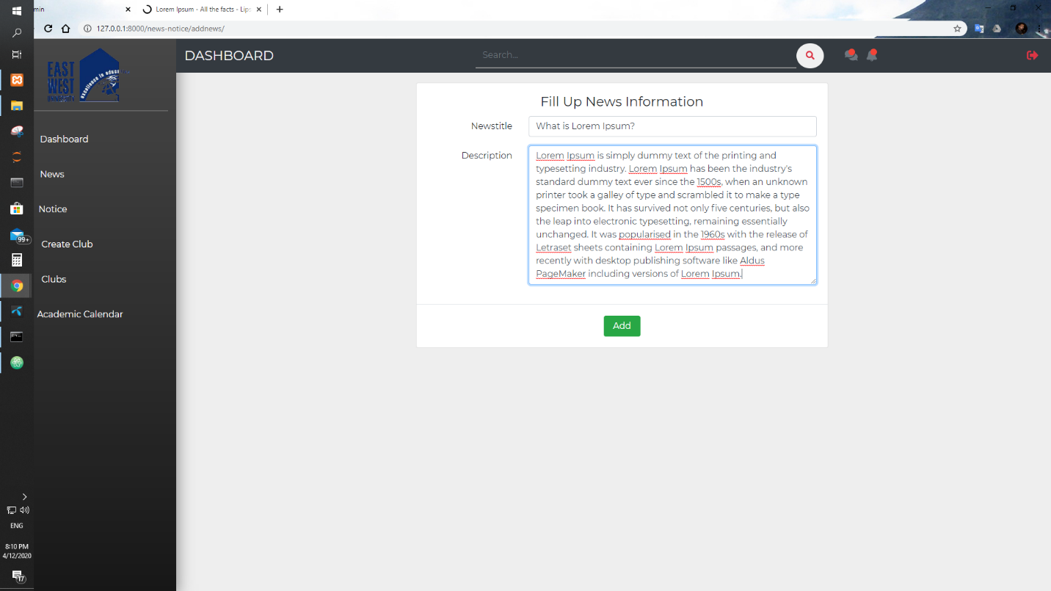

4) University authority can add recent notice

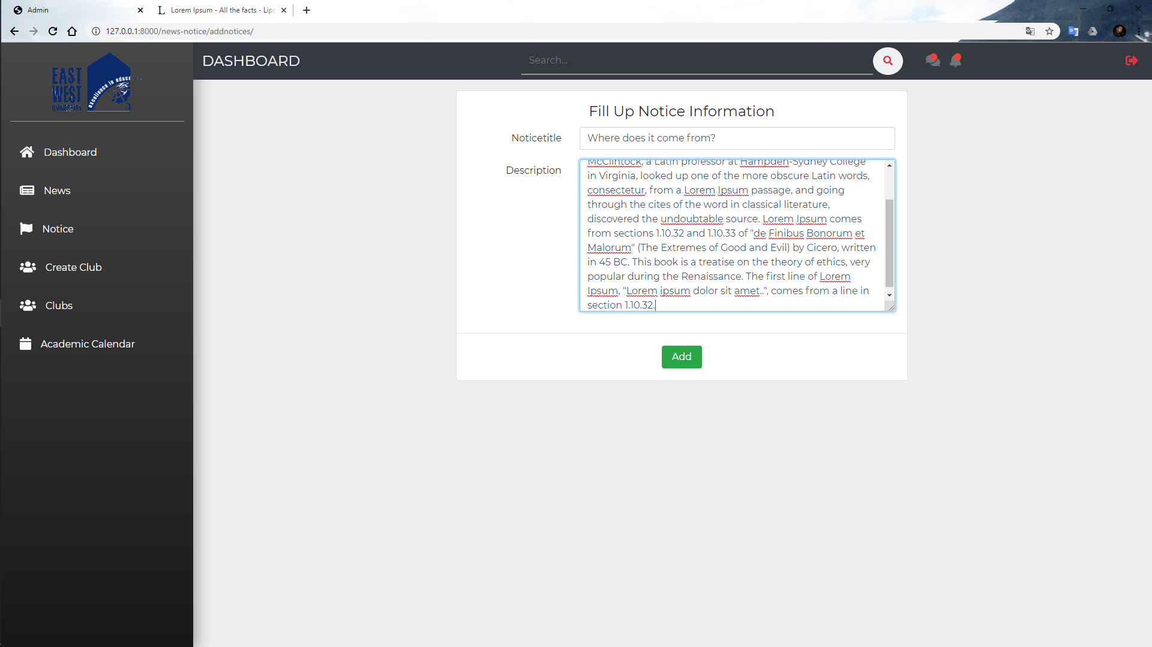

5) University authority can see all added news and can delete unnecessary news

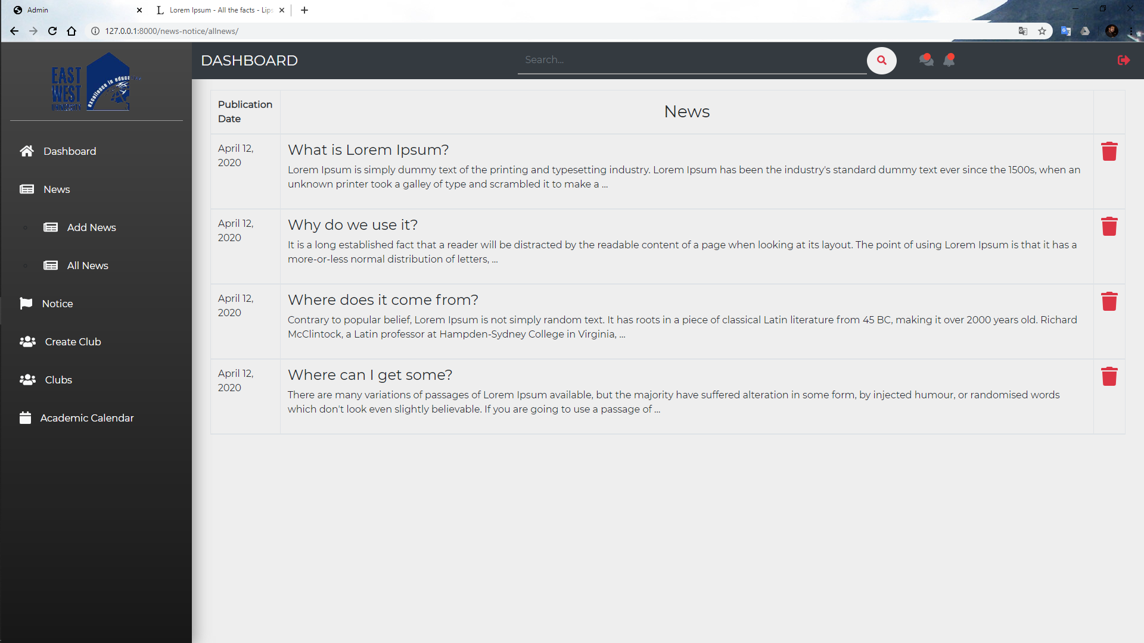

6) University authority can see all added notice and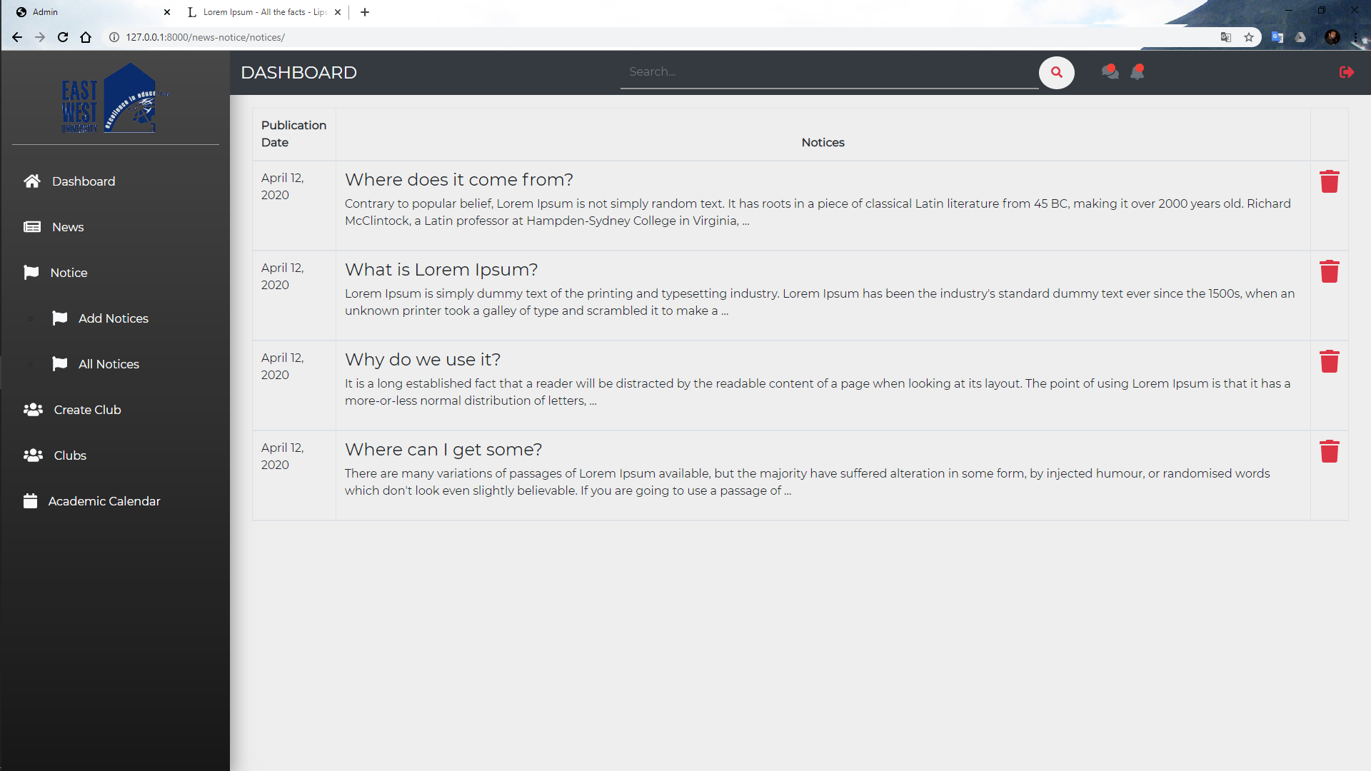 can delete old notice

7) University authority can add new club

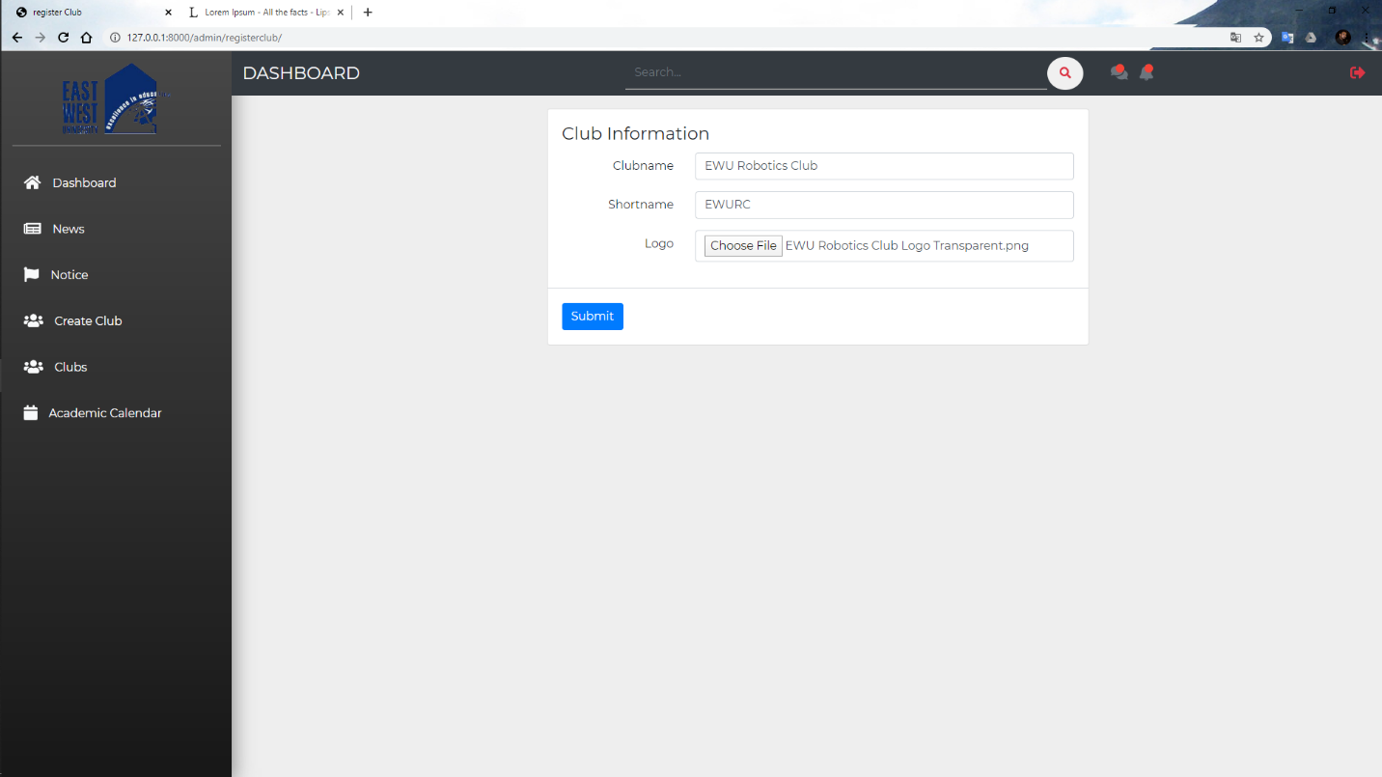

8) University authority can see all clubs in university. Authority can temporary disable club.

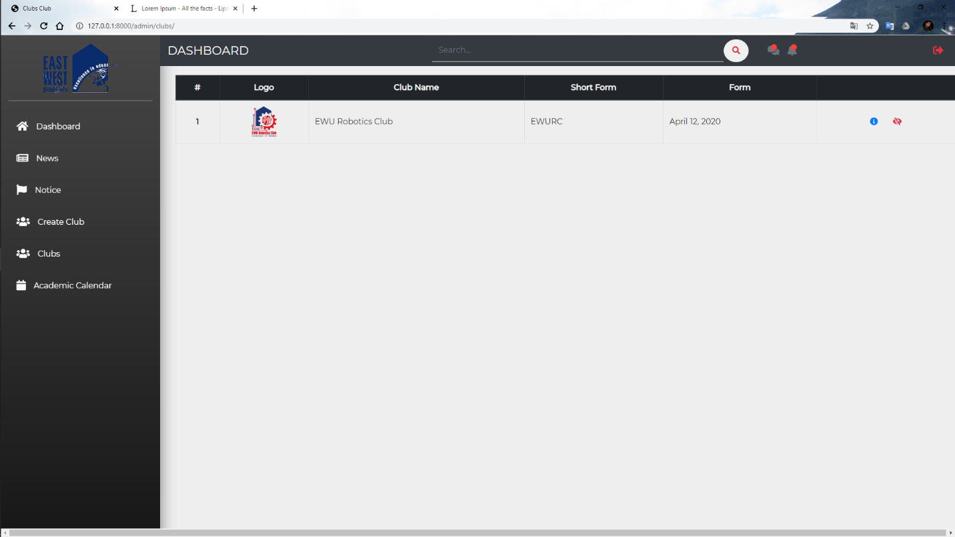

9) University authority can add an executive member of every club.

i) Search by email address for adding an executive member.

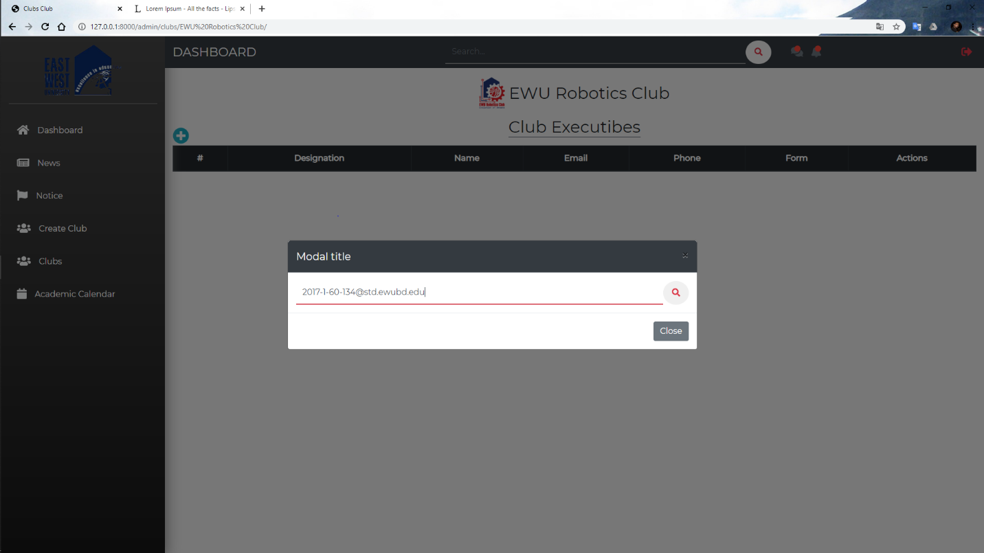

ii) If the email is valid for if this user has ability to be an executive member authority can add him.

The ability is checked by the following information

Is he an executive member of another club?

Is he an admin?

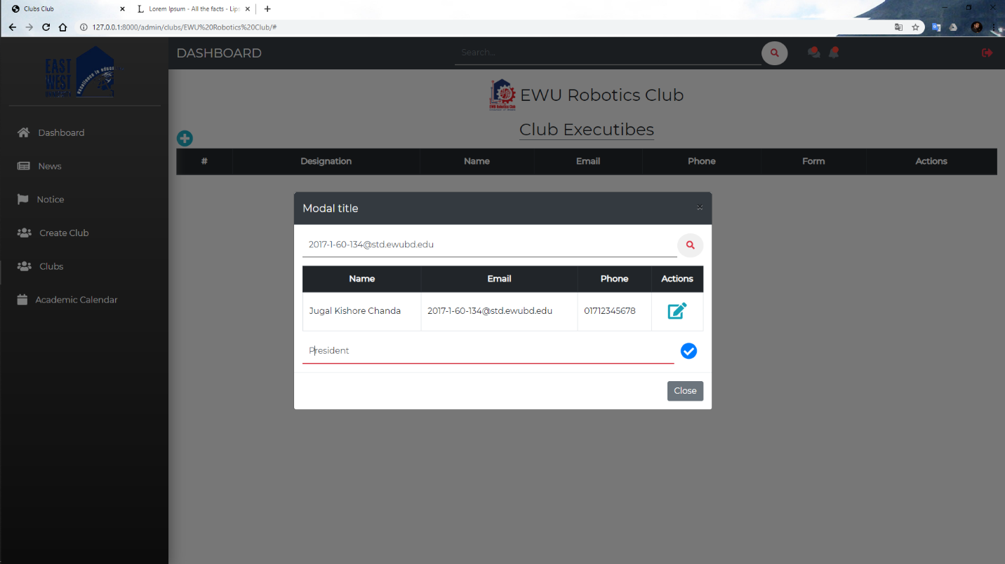

10) Authority can change an executive by deleting this executive and adding a new executive.

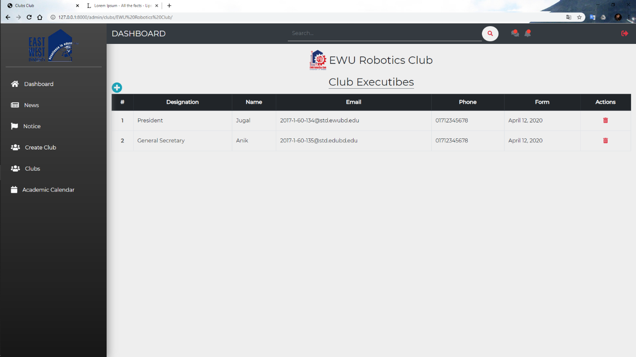

11) The authority can add an academic calendar.

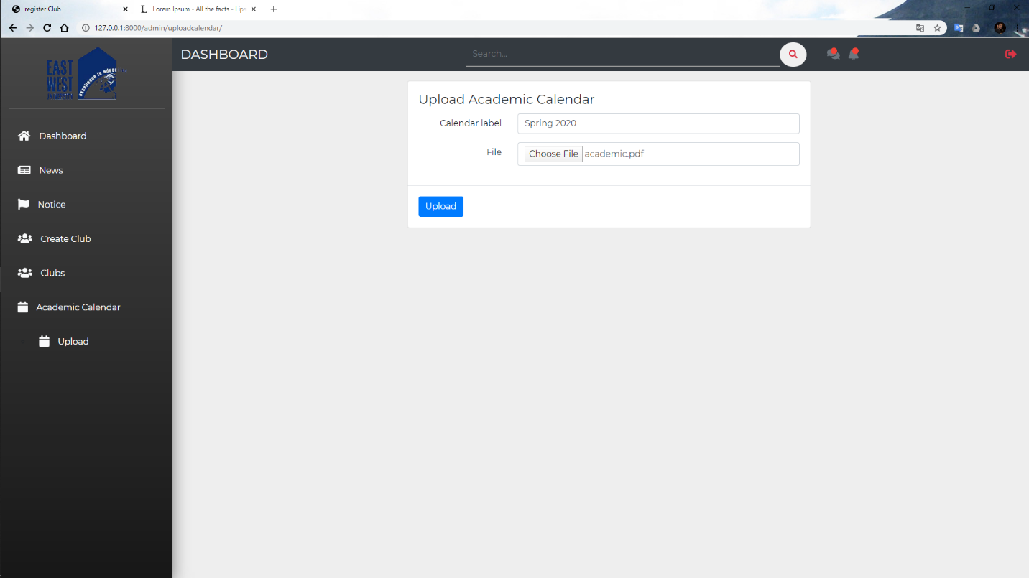

Now let’s see how the club creates an event.

12) At the first student login to this platform. If he is an executive member of any club and this club is active then he can see the club dashboard.

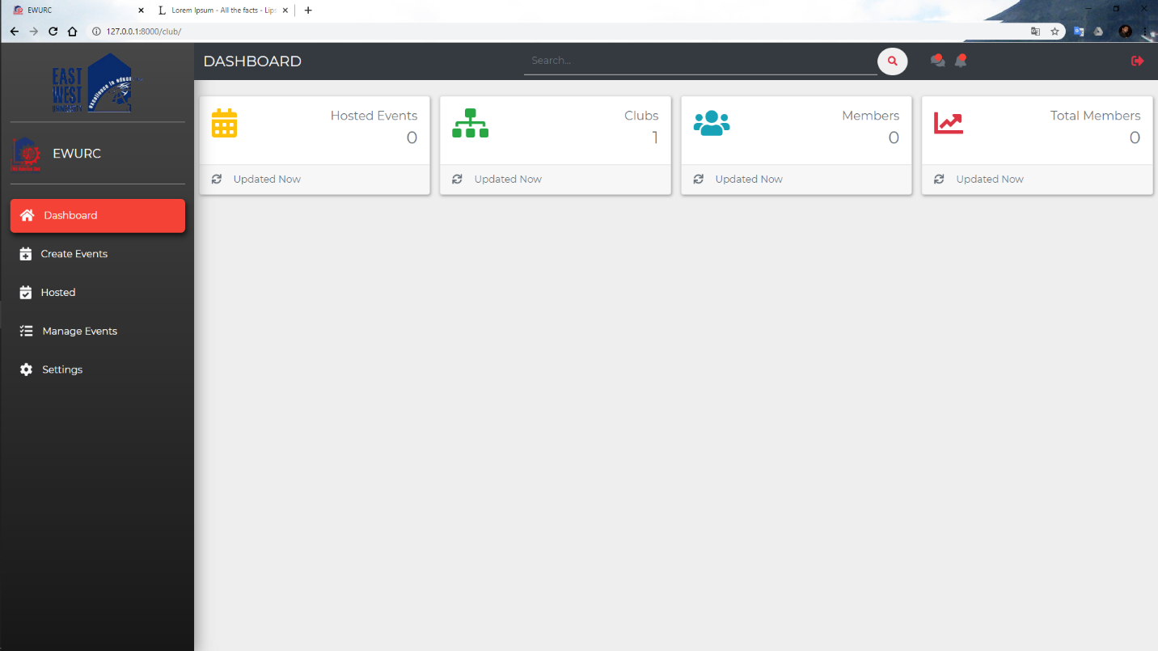

13) Executives can create an event for their club by giving the following information.

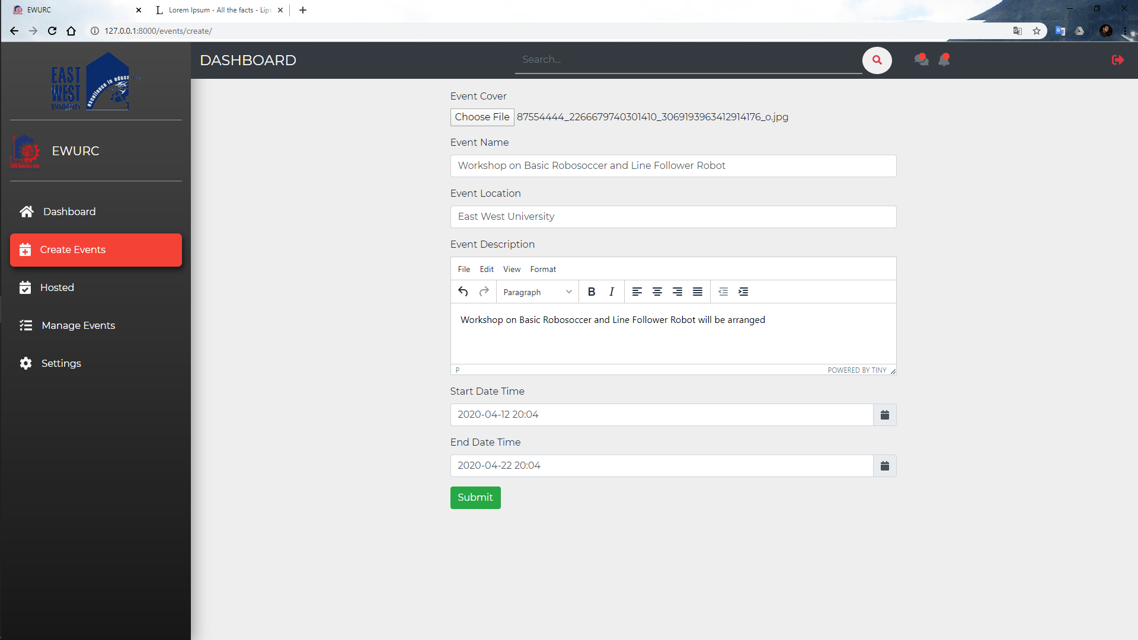

14) Executive can see all previous events hosted by this club

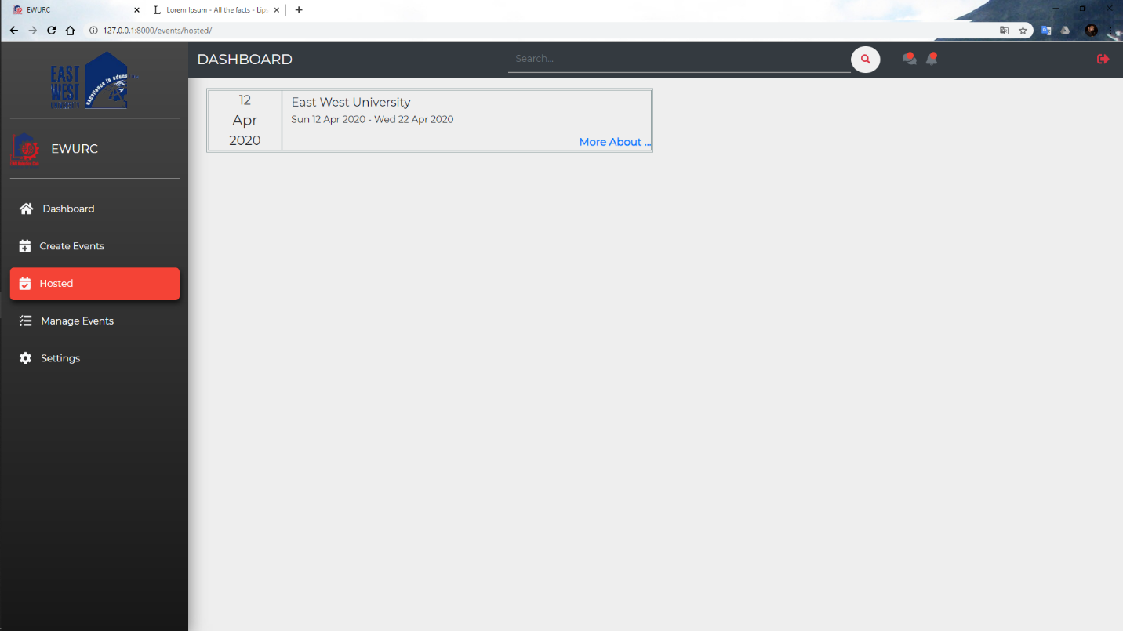

15) And see event information

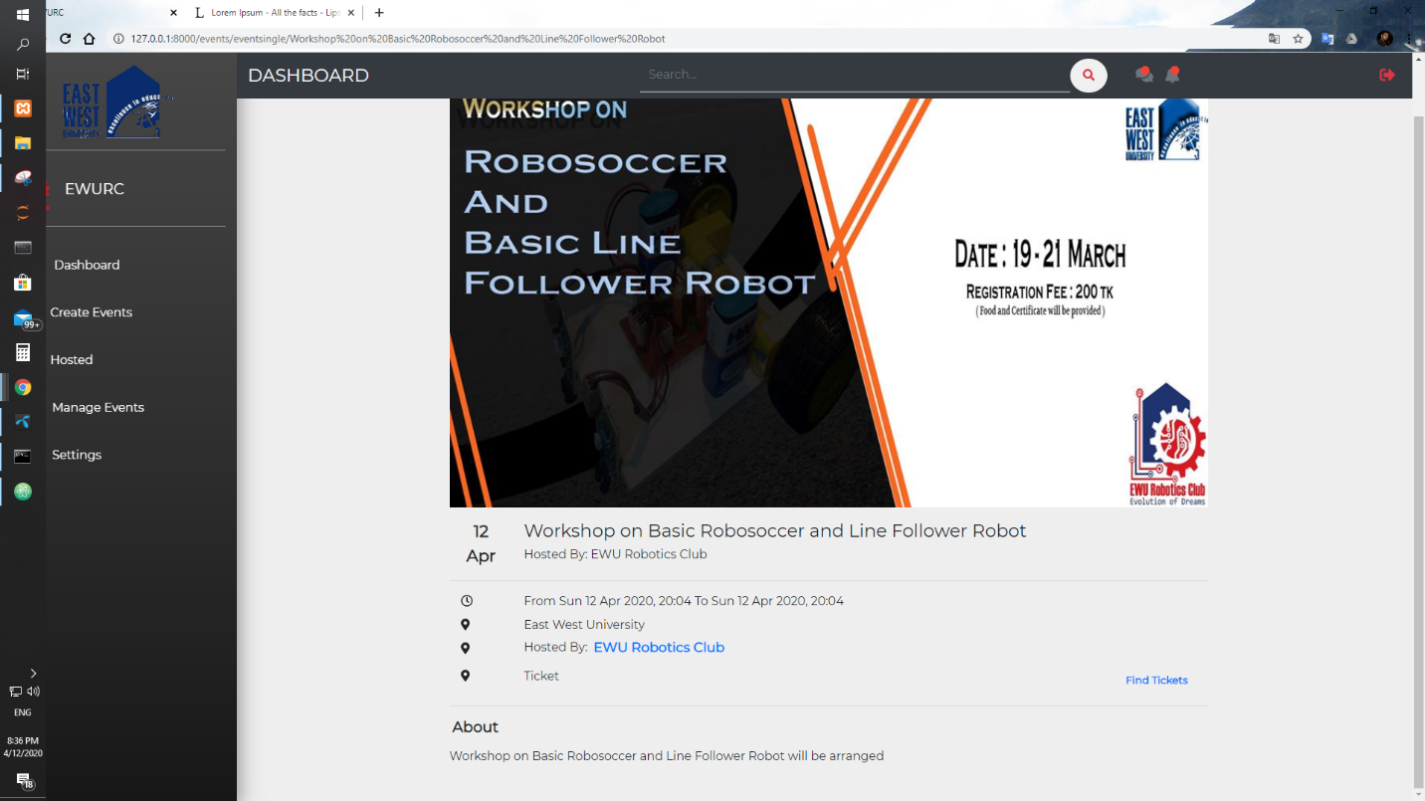

Now it’s time to see how users can register for this event.

16) General user view of this platform

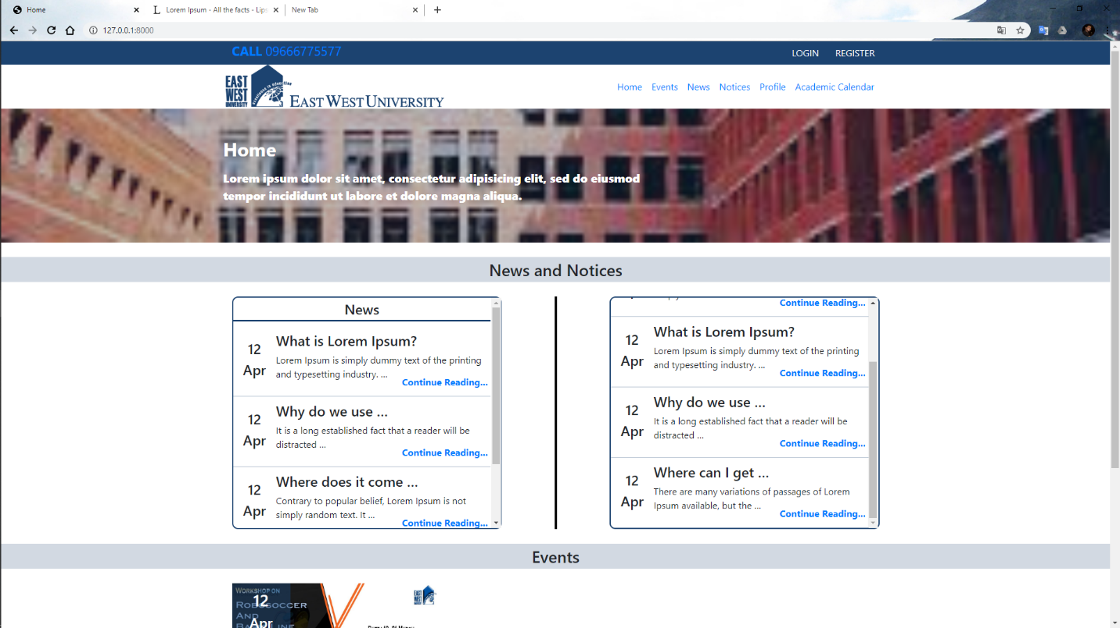

17) Go to events and see all events.

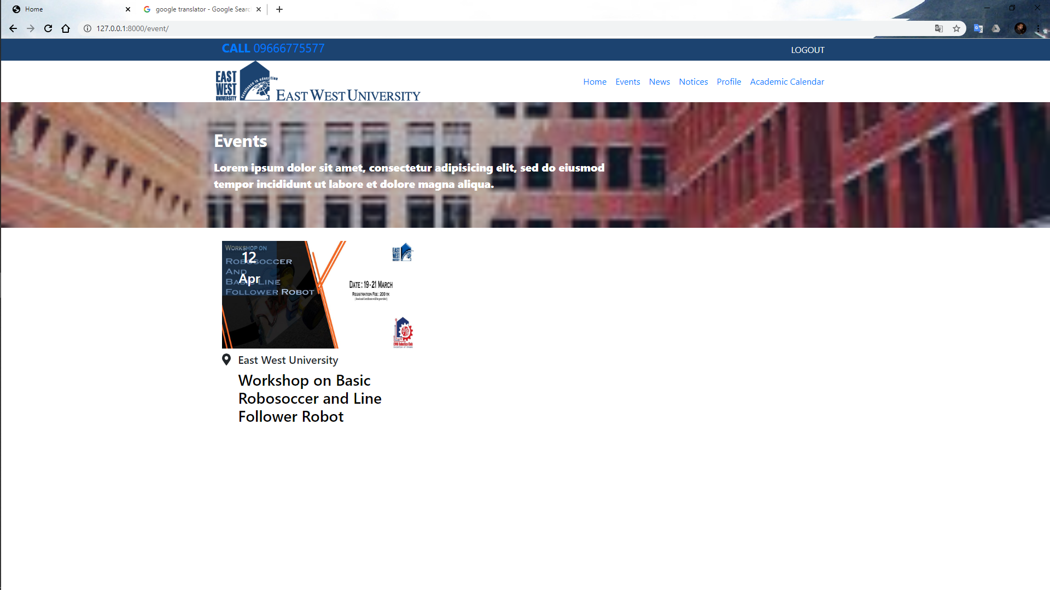

18) After choosing one event user can see this

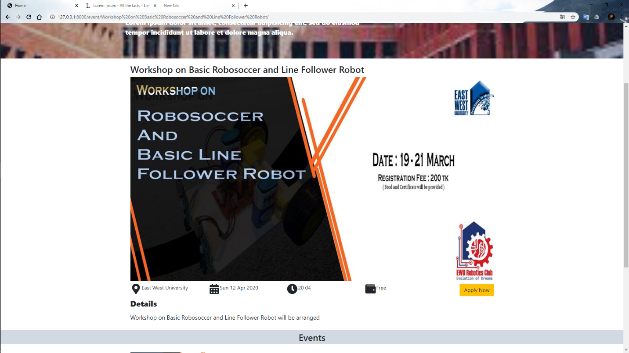

19) Clicking the apply now button and user registration form. After filling up this user can register in the particular event.

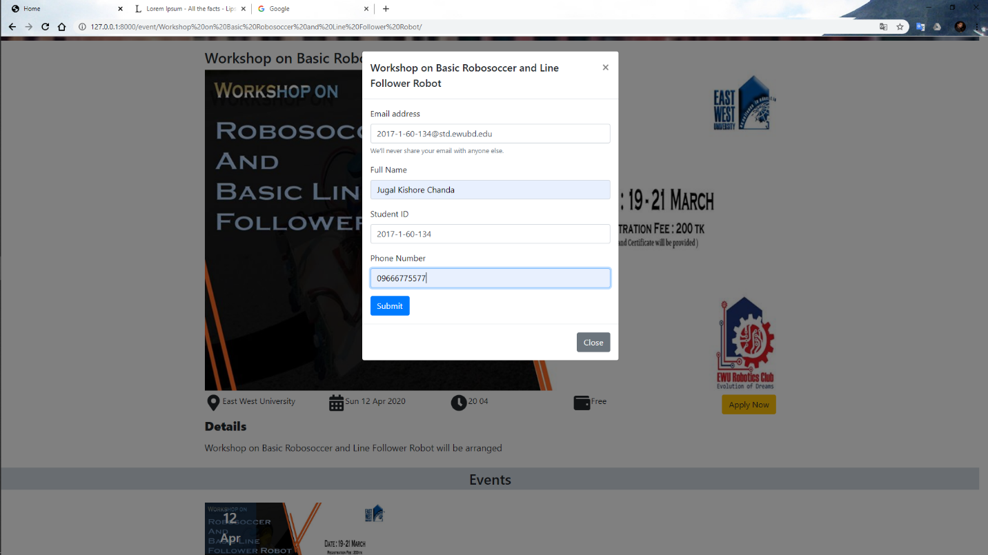

Now again go to the club view.

20) Executive can see who register for this event and their information are

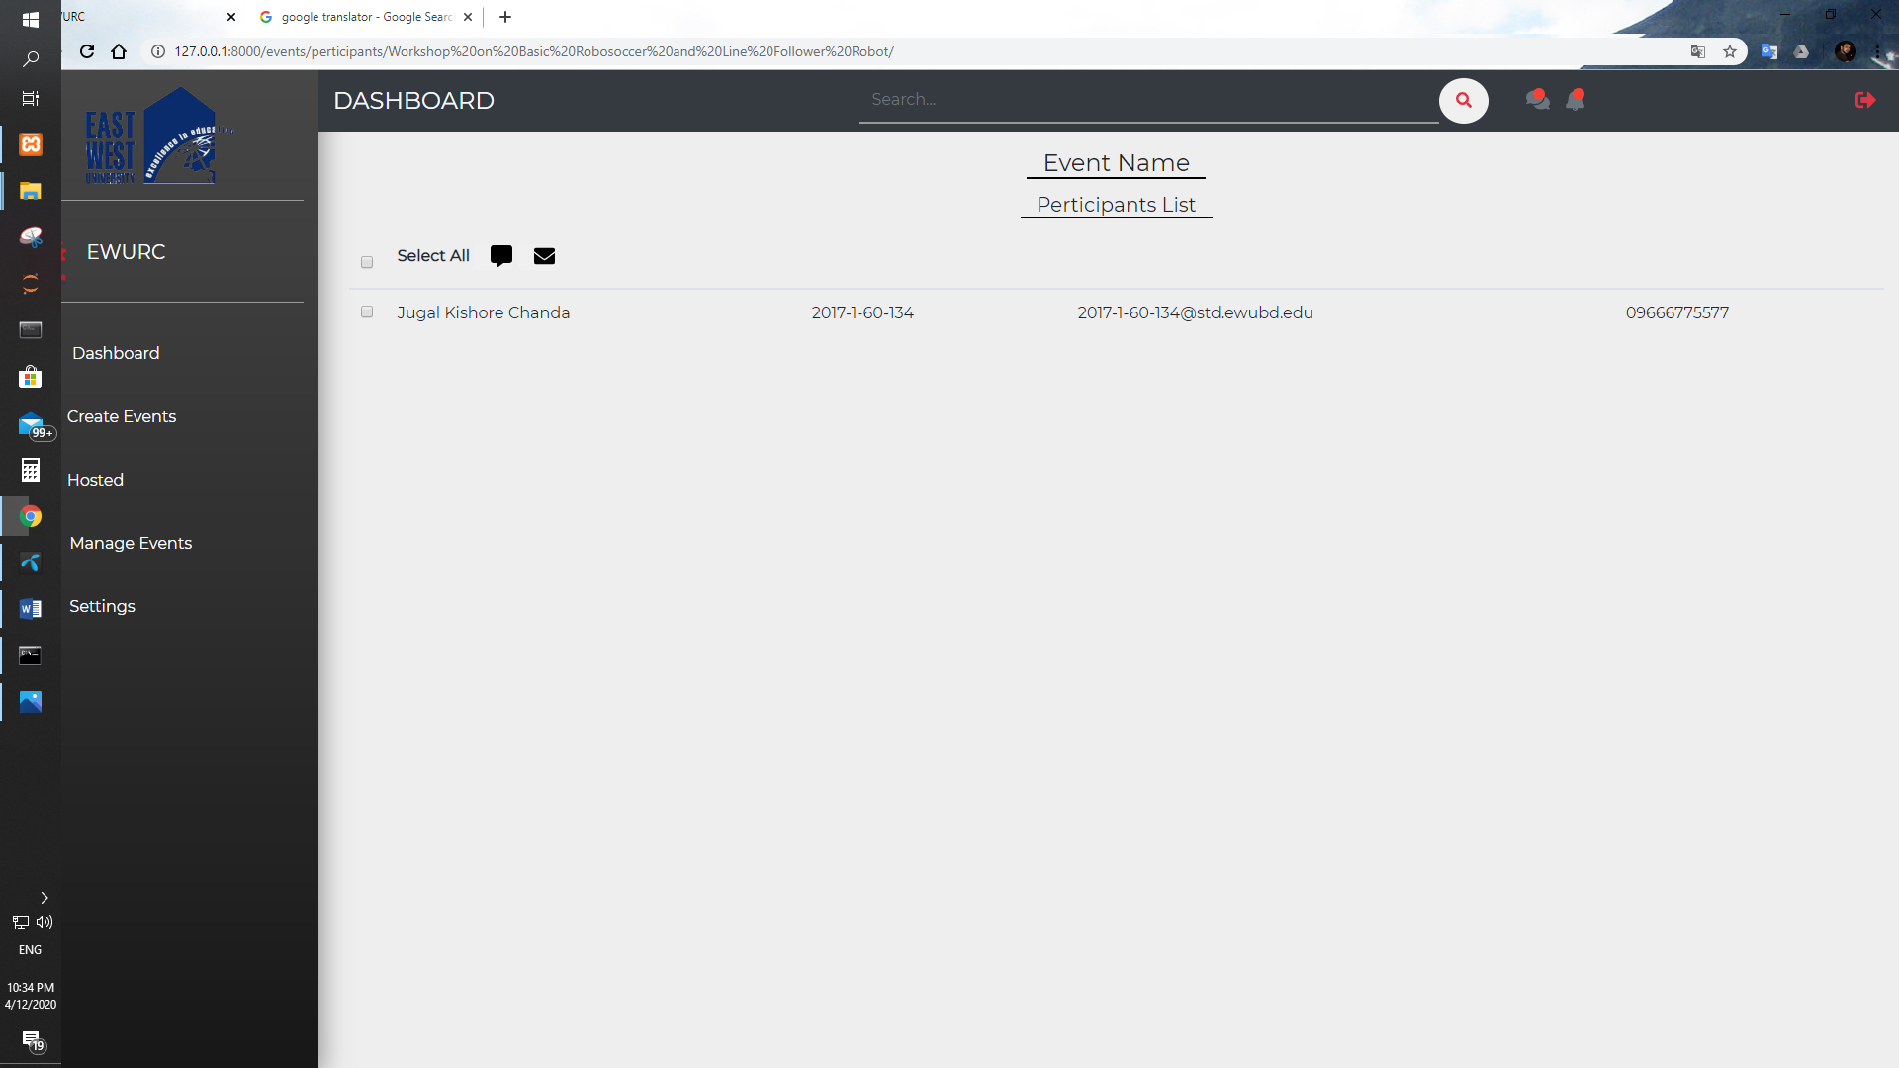

21) Executives can send email by following formats.

i) To select participants who are allowed to receive this email.

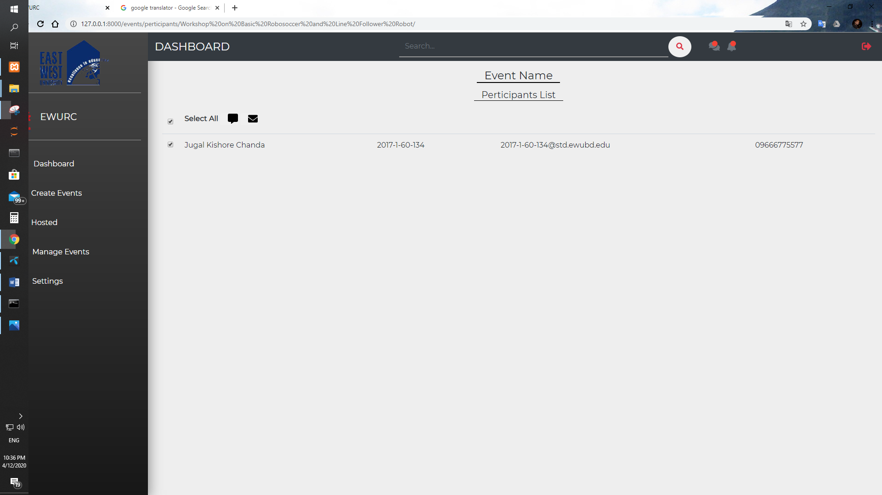

ii) Then clicking email or envelope icon for sending email. Form option they can use participant name, participant student id etc. In email.

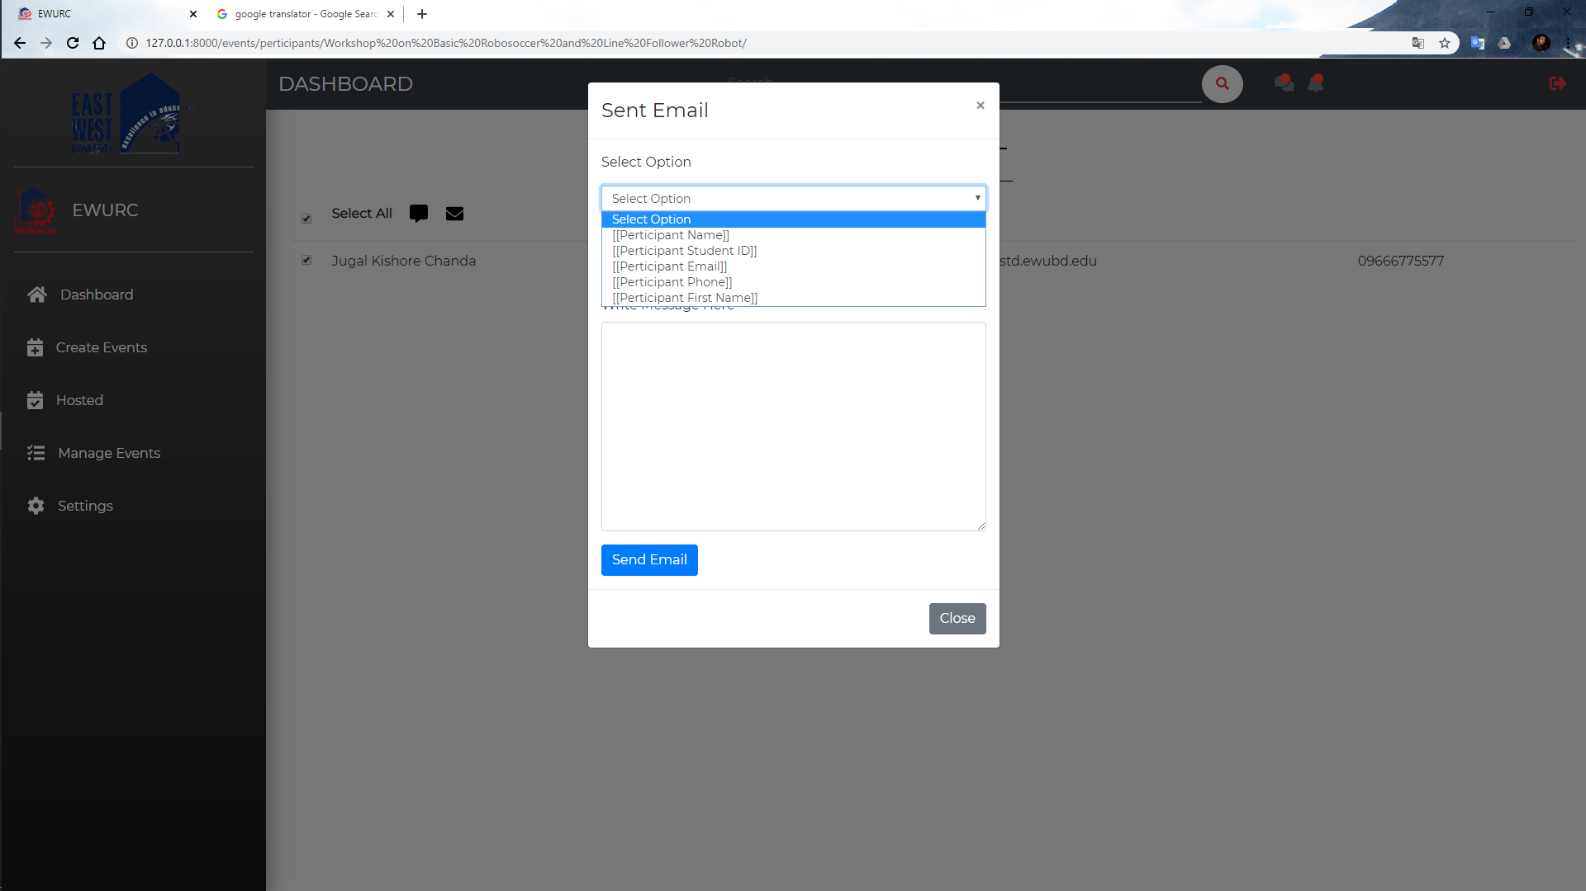

iii) After giving all the information EXECUTIVE can send email to the participants.

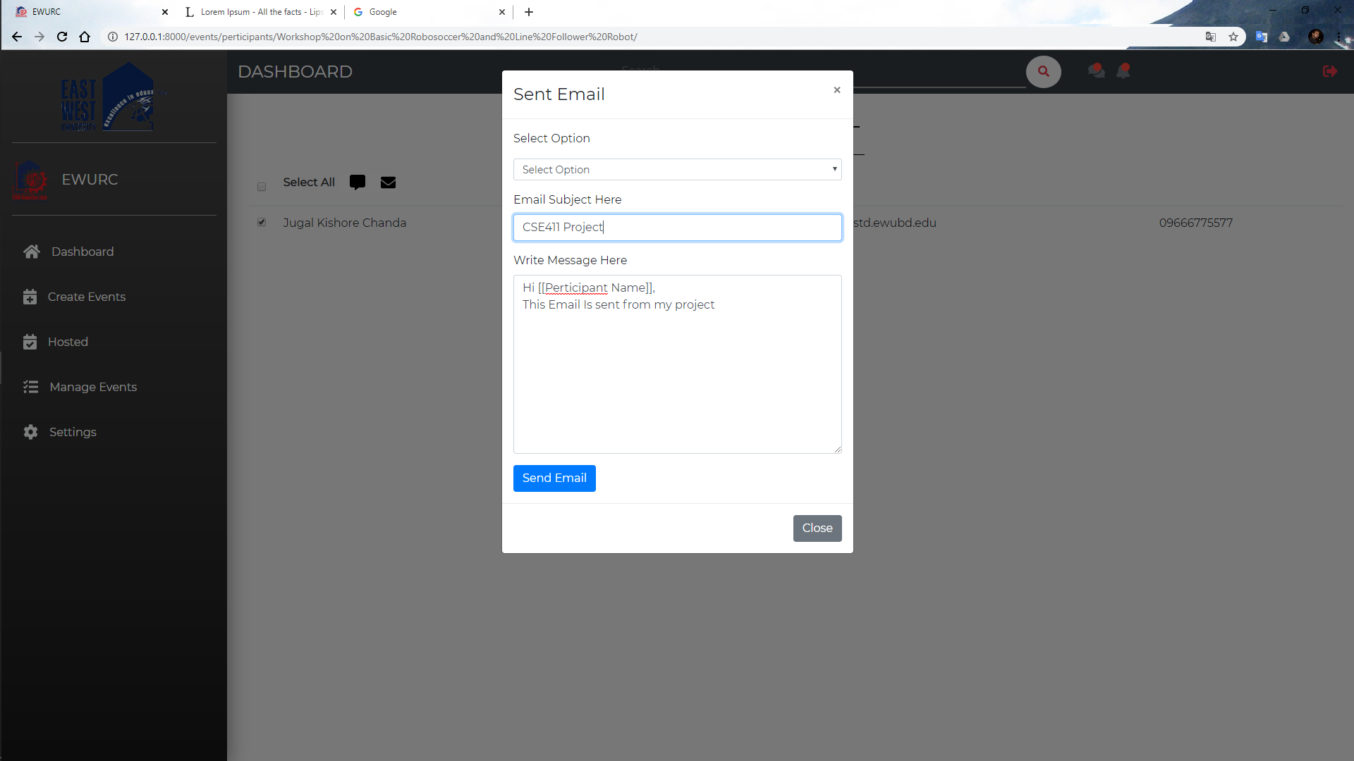

22) Before sending an email, clubs need to give their email address and email password. The email is sent from this email. It is set by going to settings option.

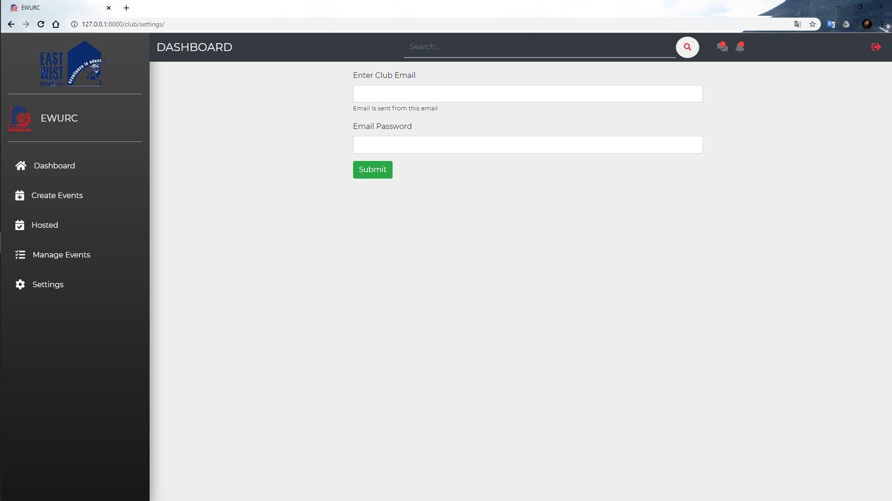

23) Users can see all the news.

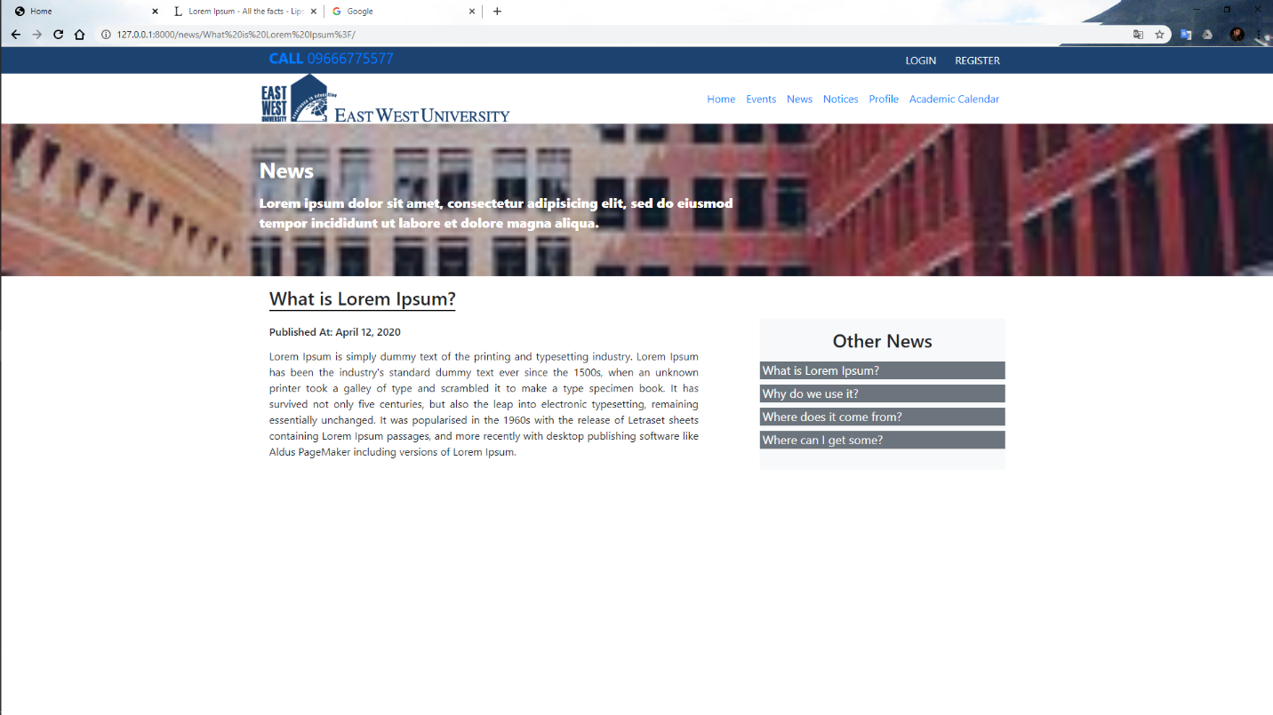

24) Users can see all notices.

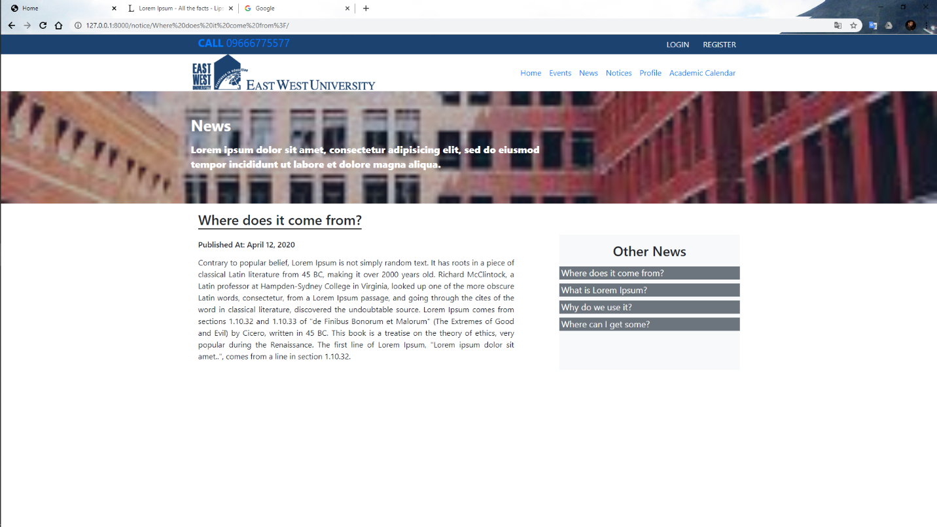

25) Users can see the academic calendar of this university.

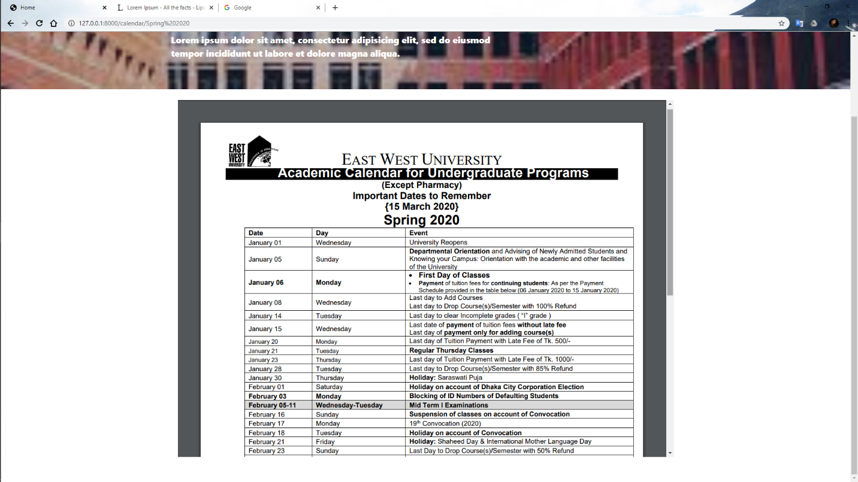

## 3.2 Hardware Interfaces

## The minimum hardware requirements of that supported to install a web browser that can easily access the internet, Minimum 4gb ram, 500gb storage, server .

## 3.3 Software Interfaces

To run this application, we need a browser.

## 3.4 Communications Interfaces

This application needs a good internet connection.

# 4. System Features

The clubs can open an event in this system and manage the event through this system properly by following this way

* + The Admin can create an event on this platform from the Register Event page.
  + There will be an option for the admin to notify all the students so that the interested students can register for participating in the Event.
  + The Event Representative can also conduct an interview after all the students have registered.
  + They can manage all of the student’s information by this system and they can download student information from this system.
  + They can make certificates for the students through this system. For this we give some template of certificates. They need to use one of them to make a certificate.

# 

# 

# 5. Other Nonfunctional Requirements

## 5.1 Performance Requirements

• Response Time

• Workload

• Scalability

• Platform

## 5.2 Safety Requirements

The member's personal information and the record of their progress should not be used to define any activity or event directly.

## 5.3 Security Requirements

To verify that a user is a student, they must authenticate using their mobile number or college email address.

## 5.4 Software Quality Attributes

<Specify any additional quality characteristics for the product that will be important to either the customers or the developers. Some to consider are: adaptability, availability, correctness, flexibility, interoperability, maintainability, portability, reliability, reusability, robustness, testability, and usability. Write these to be specific, quantitative, and verifiable when possible. At the least, clarify the relative preferences for various attributes, such as ease of use over ease of learning.>

## 5.5 Business Rules

The main admin authority has powers to create the club, ban or permit the club if needed. If a particular club requests funding, he or she may also approve the funding for that club.